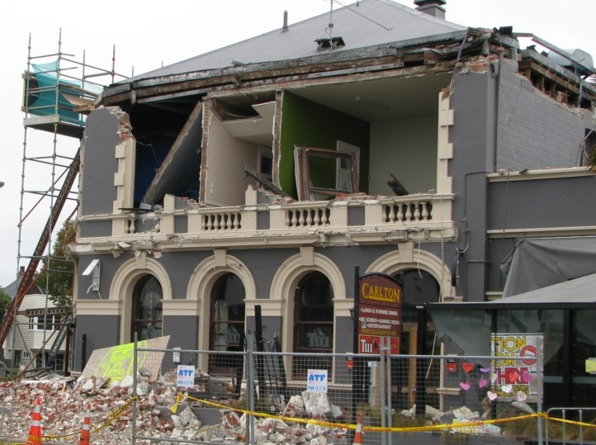
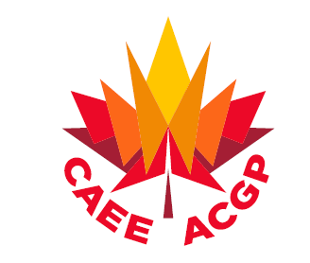

Inside This Issue
From the Editor’s Desk 1
Two APEGBC Initiatives on Post-Disaster Resilience 1
Code Corner 3
CAEE Announcement for Students 4
News 5
Upcoming Events 5

Contributed by Peter Mitchell

APEGBC to Help Develop Tools to Increase Post-Disaster Community Resilience
A major earthquake, flood, wildfire or tsunami could cripple BC communities and leave thousands of residents homeless, with many buildings and residences no longer safe to occupy or even enter.
APEGBC is partnering with BC Housing, the Architectural Institute of British Columbia and the Justice Institute of British Columbia to design a framework that will enable communities to manage and recover more quickly from major disasters.

From the Editor’s Desk
by Tuna Onur

Happy Canada Day!
We would like to take the opportunity, in this summer issue of the CAEE Newsletter, to request your contributions for the future issues of the Newsletter. There are various items you can contribute: i) a short article on your latest earthquake research or project (this could be a summarized version of a longer paper or report you have written), ii) information on notable earthquakes; iii) highlights of an earthquake safety related initiative in your community; iv) student activities related to earthquake engineering; v) short news items you would like to share; vi) and any upcoming events that you would like to highlight. This is not an exhaustive list, so please feel free to share any item that you think would be interesting to fellow earthquake engineers!
We also welcome any feedback on the Newsletter. Please send all contributions and/or feedback to secretary@caee-acgp.ca

Two APEGBC Initiatives on Post-Disaster Resilience
Canadian Association for Earthquake Engineering (CAEE)
L’Association Canadienne du Génie Parasismique (ACGP)
July 2017
Volume 2, Issue 2

Newsletter

http://caee.ca/

The framework will allow communities experiencing a disruptive emergency to quickly assess the safety of structures and allow people to remain in or return to their homes and businesses as soon as possible, thereby increasing the communities' resilience.
The Canadian Safety and Security Program Post-Disaster Damage and Safety Assessment of the Built Environment is the first such project in Canada. Although developed in BC, the assessment system will be scalable and apply to rural and urban communities of all sizes throughout Canada.
Damage assessment gauges the type, quantity, cause and sometimes cost of damage to a building and can include an evaluation of the repairs needed. Safety assessment determines whether the building can be occupied and used immediately and, in some cases, identifies short-term countermeasures to reduce risk in order for the building to be occupied.
The goal of the two-year, multi-agency research project is to develop tools, models, processes and approaches to empower community-level professional and public engagement in emergency planning and safety assessment. Specifically, the research team will develop a model that allows, enables and supports credentialed and non-credentialed members of the public to assess safety in an emergency situation. Such a model would reduce the social impact of disruptive events, allowing communities to recover more quickly and reducing impact on emergency and social services.

Defence Research and Development Canada is funding the post-disaster damage and safety assessment project.
APEGBC to Prepare Post-Earthquake Building Evaluation Training
APEGBC will be developing a training program for post-earthquake building evaluation with a portion of the funding for emergency preparedness announced by the BC government in March.
"This training program will combine the latest research with engineering expertise to provide a way to rapidly and effectively evaluate the safety of buildings following a seismic event:' says APEGBC CEO and Registrar Ann English, P.Eng. "By equipping a pool of qualified professionals with the necessary tools and techniques to perform these assessments, we will be better able to respond to the needs of the community in an emergency situation:" The training program will be based on the methodology employed in APEGBC's award-winning Seismic Retrofit Guidelines, 2nd edition (SRG2), and will be delivered for qualified professionals, such as engineers, architects, building inspectors, and those identified as post-earthquake administrators. The goal of the project is to create a professional community with the specialized skills to provide post-earthquake structural assessments and aid in the immediate response and recovery efforts of all levels of government.
For more information on these two APEGBC initiatives, contact Peter Mitchell, APEGBC Director, Professional Practice, at mitchell@apeg.bc.ca or 604.412.4853.

He touched the lives of many of his students as a great mentor and educator. He will be deeply missed!
Two APEGBC Initiatives… Continued from Page 1

“The additional PBD steps [in seismic design] provide the owner with increased understanding of and confidence in the post-earthquake bridge performance”
In Volume 2 Issue 1 of this Newsletter, we started to provide a more detailed overview of the CSA S6-14, Canadian Highway Bridge Design Code (CHBDC).
In this issue, we continue to highlight the CHBDC and issues in seismic design of bridges in Canada.
Performance Based Design
CSA S6-14 formally introduced a performance-based seismic design (PBD) framework for transportation structures in Canada. For important and irregular bridges in higher seismic zones, PBD is required. For any structure, it is an acceptable or encouraged design approach. Two key differences of PBD compared to force-based design (FBD, reducing elastic demands using "R" factors in recognition of ductility) are that: (1) PBD adds an explicit calculation of damage states and an assessment of the related return to service expectations under three different return periods, and (2) the designer has a means of designing a variety of lateral load-resisting systems that were not previously emphasized or even considered. S6-06 essentially considered elastic force-based design, ductility (FBD), and base isolation. Each of these are valid in PBD, although in higher seismic zones ductility and base isolation can provide significantly improved seismic resilience compared to design to elastic forces. Resilience in this context can be considered as a larger and more reliable reserve margin of lateral capacity, and a more rapid return to service during or after the main event or during a period of aftershocks.
While a conservative design using elastic forces can provide a reserve margin, typically the structure is strong but remains brittle. In the days following the Northridge Earthquake in northern Los Angeles in 1994, a local newspaper edition with extensive coverage of the aftermath was critical of Californian bridge design practice (understandably, since several bridges had collapsed) but presented the practice of robust strength-based design used in Japan as preferable. Shortly thereafter, the 1994 Kobe earthquake illustrated the inherent and important limitations of strength-based seismic design. It is doubtful that any major region in high seismic zones has emphasized strength-based design since the 1990s.
Ductility-based design in the FBD framework remains a fundamentally important building block in many cases for the design and proportioning of bridge sub-structures for lateral loads. It can also be a pragmatic first step in the PBD approach for bridges. A lateral-load resisting bridge system that has been appropriately arranged and proportioned, and has ductility ensured through capacity-based design, good detailing and quality control during construction, should inherently possess a high degree of seismic resilience. The additional PBD steps including the assessment of failure modes, damage states, expected return to service and repairability are intended to provide the design and Owner with increased understanding of and confidence in the post-earthquake bridge performance. The increased engineering effort is inconsequential compared to providing seismically resilient and reliable bridges to our communities for the days and months following large earthquakes.

By Don Kennedy

Code Corner

CAEE Announcement

for Students
Base Isolation
Base isolation has been given considerable attention in CSA S6-14, being a well-demonstrated 'low-damage' lateral load resisting system. CSA S6-14 may be found in practice to encourage the use of base isolation in bridges. This would be a positive outcome. The ability of seismic isolation to provide reliable, repeatable low-damage performance during large earthquakes and aftershocks can be advantageous in new bridges and certainly in the retrofit of existing bridges. As noted previously, other low-damage seismic systems can also be employed, provided that appropriate analyses, damage and service assessments, consideration of past performance or risks, attention to detail, and independent reviews are properly completed.
In the coming Code Corner column, we will provide guidance and examples of damage states inherent to CSA S6-14 and also to the British Columbia Ministry of Transportation and Infrastructure (BC MoTI)'s Supplement to S6-14. The BC MoTI supplement adopted revisions to damage states for sub-structures and for geotechnical systems. While CSA S6-14 remains the current standard, the BC MoTI supplement provides improvements and supplemental descriptions that are expected to allow PBD to remain economically achievable for a wider range of bridges on both firm and softer soils. We note that there will be a theme session on the seismic PBD within the coming IABSE Symposium in Vancouver, Canada in September (see Upcoming Events on Page 5 for details) which will illustrate recent findings of PBD to highway bridges in Canada.
S6-14 is available for purchase at: http://shop.csa.ca
The BC MoTI Supplement may be downloaded at: http://www2.gov.bc.ca/gov/content/transportation/transportation-infrastructure/engineering-standards-guidelines/structural/standards-procedures/volume-1
The Ontario document listing exceptions is at: http://www.ceo.on.ca/files/CHBDC 2014 Letter to CEO (attached).pdf

CAEE is currently soliciting interested students (graduate or undergraduate) to serve on a new Student Activities Committee. The goal of this committee is to facilitate the engagement of graduate and undergraduate students at Canadian Universities with the practice of Earthquake Engineering. This is intended to include aspects of both professional practice and academia.
One of the first mandates of this committee will be to organize and run a national “blind-analysis” competition of a shake table test.
Additionally, if any members are aware of non-member students who may possibly be interested in joining this committee, please pass on this message to them. Remember that membership in the CAEE is currently still free!
Interested students should please contact the board liaison for the Student Activities Committee, Prof. Jeff Erochko at jeffrey.erochko@carleton.ca

Code Corner Continued from Page 3

CAEE Research Committee continues to seek your assistance in compiling a catalogue of Canadian Earthquake Engineering research activities. Results of this survey will be available on the CAEE website. If you are interested to participate, please respond with the following information to dowlingj@ae.ca and/or Yavuz.Kaya@gov.bc.ca
- A list of 3 to 6 keywords describing your current research activities
- More information on your primary areas of research (~100 words)
- Your current title
- If you are a Professor, number of graduate students you have

Thank you for your time and we appreciate your contribution,
CAEE Research Committee.
We are soliciting news items, announcements, and events to publish in this column. Please let us know if you hear of earthquake engineering related events.
Upcoming events
39th IABSE Symposium – Engineering the Future
21-23 September 2017
Vancouver, BC
www.iabse.org/Vancouver2017

4th International Conference on Earthquake Engineering and Seismology
11–13 October 2017
Eskisehir, Turkey
www.tdmd.org.tr

SSA 2018 Annual Meeting
24-26 April 2018
San Juan, Puerto Rico
www.seismosoc.org/meetings/

Geotechnical Earthquake Engineering and Soil Dynamics Conference V
10-13 June 2018
Austin, Texas
www.geesd2018.org

16th European Conference on Earthquake Engineering
18-21 June 2018
Thessaloniki, Greece
www.16ecee.org

11th U.S. National Conference on Earthquake Engineering
25-29 June 2018
Los Angeles, California
11ncee.org

7 ICEGE 2019 - International Conference on Earthquake Geotechnical Engineering
16-20 June 2019
Rome, Italy

News
CAEE Research Committee is Seeking Your Contribution
We’re on the Web!
Visit us at:
http://caee.ca

News and Upcoming Events

CAEE

Dept. of Civil Engineering

Univ. of British Columbia

6250 Applied Science Lane Vancouver, BC,

Canada V6T 1Z4

Fax:

604-822-6901

E-mail:

secretary@caee-acgp.ca

